**OPS102 – Week 4 – File Systems**

Student Name: Chetan Arora

Student ID: 100976240

**Activity 1: Redirection and Piping**

Put following text to a file called gpt.txt

ChatGPT is an artificial intelligence chatbot developed by OpenAI and released in November 2022.

The name "ChatGPT" combines "Chat", referring to its chatbot functionality, and "GPT", which stands for Generative Pre-trained Transformer, a type of large language model.

Wikipedia

ChatGPT has been trained on huge amount of data scraped from internet.

This has enabled us to develp artificial programes that can answer questions like humans.

**Redirection:**

Redirection can send input to a command from a file or can send output of a command to a file.

Input redirection symbol: <

**Command < filename**

1. Run the command on Linux: **cat < gpt.txt**

What do you see and why?

Ans:-

The cat< gpt.txt command will show the contents of the gpt.txt on the terminal screen.

1. Run similar command on Windows: **TYPE < gpt.txt**

What do you see and why?

Ans:-

The Type command of Windows operating system is similar to the cat command of Linux. The type< gpt.txt command will show the contents of the gpt.txt on the terminal screen.

Output redirection symbol: >

**Command > filename**

1. Run the command on Linux **ls -l > list.txt**

What is the output? Explain

Ans:-

The ls -l > list.txt command is used to create a list.txt file with the content of detailed list of the files and directories which is present in current directory.

1. Run equivalent command on Windows: **dir > list.txt**

What is the output? Explain

Ans:-

The dir > list.txt command of Windows operating system is similar to the ls -l >list.txt of Linux command. The dir > list.txt command is used to create a list.txt file with the content of detailed list of the files and directories which is present in current directory.

1. Run the command on both Linux and Windows: **sort < list.txt**

What is the output?

Ans:-

The command sort < list.txt used to sort the lines of the file list.txt in alphabetical order and display the output on the terminal screen.

**Piping:**

**Command1 | Command2**

Piping is used to redirect output of first command to the input of the second command. This allows to combine simple commands to achieve more complex task.

Perform following tasks and add screenshots

1. On Linux run the command **ls /bin | more**

What do you see and why?

Ans:-

The ls /bin | more command used to see the files and directories of /bin directory on the terminal screen and |(pipe operator) this symbol is used for run another command at the same time. The more command is a pager command which allows to view large amount of text in a terminal screen step by step.

1. Suppose you have a text file called gpt.txt having following text in it

On Windows run the command **TYPE gpt.txt | FIND “GPT”**

What is the output? Explain it:

(TYPE is equivalent to cat command on Linux)

Ans:-

The command TYPE gpt.txt | FIND "GPT" is used to display the lines of the file gpt.txt that contain the string “GPT”.

1. Run and explain the command: **cat < gpt.txt | sort > out.txt**

Explain what is happening in above command?

Ans:-

The command cat <gpt.txt| sort > out.txt performs, it read the contents of gpt.txt file and sort the text by alphabetical order then store this new sorted text in out.txt file.

1. tr 'a-z' 'A-Z' < words.txt Will change all lower case to upper in words.txt

Ans:- Yes, This command will change all lower case letters to upper case in the file words.txt and display the output on the screen.

1. sort < xyz.txt Will sort xyz in ascending order Note: -r will do in reverse order

Ans:- Yes, this command  will sort the lines of the file xyz.txt in ascending order (alphabetically or numerically, depending on the content) and display the output on the screen. The -r option can be used to sort the data in reverse order (descending).

1. PWD 2> error-message.txt for recording error message

Ans:- The PWD 2> error-message.txt command is used to print the current working directory to the output on terminal screen and redirect the error messages to the file error-message.txt.

1. ls | grep Linux | head -5 To test make some files with Linux1, Linux2 etc.

Ans:- It will display the first five files or folders that have Linux in their name.

**Activity 2: File Permissions**

Practice: Convert 7, 6, 5 and 4 into binary

Ans:- 7 = 111, 6 =110 , 5= 101, 4 = 100

Find octal value of 101, 001, 010, 011

Ans:- 101 = 5, 001 = 1, 010 = 2 , 011 = 3

Consider following image for next tasks

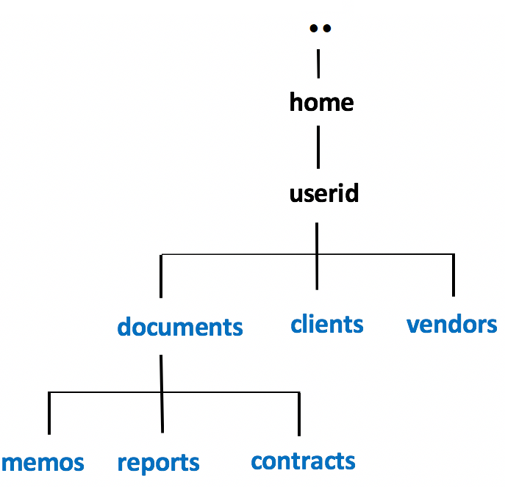

Choose any way to create following files in the respective folders

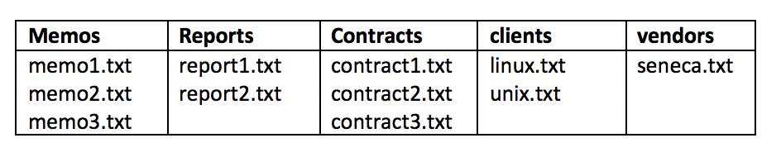

1. Issue the following Linux commands:  
   **ls -ld ~/documents ~/clients ~/vendors  
   ls -lR ~/documents ~/clients ~/vendors**

Ans:-

1. Let's limit access to the **clients** and **vendors** directories to only yourself and same group members.  
   Issue the following Linux command:  
   **chmod 750 ~/clients ~/vendors**

Ans:-

1. Issue the **ls -ld** and **ls -lR** commands (as you did in *step #8*) to confirm that the permissions for those directories have been changed.  
     
   **NOTE:** The **-R** option for the **chmod** command can change the file permissions recursively within a directory structure.

Ans:-

1. Issue the following Linux command: **chmod 750 -R ~/documents**

Ans:-

1. Issue the **ls -ld** command to confirm the permissions for the  
   **~/documents**, **~/document/memos** , **~/documents/reports**, and **~/documents/contracts** directories.

Ans:-

1. Issue the following Linux command: **ls -lR ~/documents**  
   What do you noticed happened to the permissions for the regular files contained in those directories.  
   Did those regular file permissions change?  
     
   We will now change permissions for regular text file contained in subdirectories  
   of the **documents** directory to: **r w - r - - - - -**

Ans:-

Yes, the permission of regular file has been changed.

1. Issue the following Linux commands:   
   **chmod 640 ~/documents/memos/memo*.txt  
   chmod 640 ~/documents/reports/report*.txt  
   chmod 640 ~/documents/contracts/contract*.txt**

Ans:-

1. Issue the **ls -lR** command for the **~/documents** directory to confirm that those regular file permissions have changed.

Ans:-

1. Issue the following Linux command to add write permissions for all files in the memos directory  
   for yourself (i.e. user): **chmod u+w ~/documents/memos/\***

Ans:**-**

1. chmod ugo-w ~/documents/memos/memo*.txt what this command will do.

Ans:-

1. chmod u+w ~/documents/memos/* what this command will do.

Ans:-

This command will add write permissions for the user (u) to all files (*) in the ~/documents/memos/ directory.

1. chmod u=rwx,go=x ~/linux/content what is the meaning of this command

Ans:- This command means to change the permissions of the file or directory named ~/linux/content. The u=rwx part means to give the user who owns the file or directory the read, write, and execute permissions. The go=x part means to give the group and others only the execute permission.

1. What is the meaning if a directory has read, write and execute permissions.

Ans:- The meaning of read, write and execute permissions on a directory are as follows:

Read (r): This permission allows you to read the contents of the directory. You can see the names and attributes of the files and subdirectories inside the directory.

Write (w): This permission allows you to modify the contents of the directory. You can create, delete, rename, or move files and subdirectories inside the directory.

Execute (x): This permission allows you to access the files and subdirectories inside the directory. You can open, read, write, or execute the files, or change into the subdirectories, if you have the corresponding permissions on them.

1. Issue umask 000. Check umask value. Create some files and check the permissions.

The command umask 000 will set the file mode creation mask to 000, which means that no permissions will be denied for newly created files or directories. As shown above, the files have read and write permissions for the user, the group, and others. This is because the default permissions for files are 666, and the umask 000 does not remove any permissions. If anyone create a directory, it will have read, write, and execute permissions for everyone.

Instructor Note: Use Windows Properties to show how to change file permissions